Lab 10 (2%)

MongoDB: Aggregation

Learning outcomes

Upon successful completion of this workshop, you will have demonstrated the abilities to:

1. Use the aggregation framework to transform and combine documents in a collection.
2. Run simple aggregation commands such as count, distinct and group.

Done by: Mansoor Ahmad Zafar

Data:

Restaurant-data.json

Aggregation in MongoDB

Write MongoDB queries to answer each of the following questions.

1. Unwind the restaurants collection and show the average rating per restaurant.

db.restaurant.aggregate

(

{"$unwind" : "$reviews"},

{"$group" :

{

"_id" : "$name",

"avgRating" : {"$avg" : "$reviews.rating"}

}

}

)

Output:

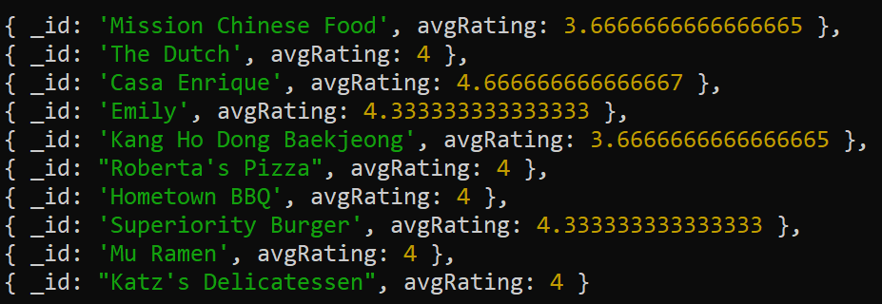

1. Unwind the restaurants collection and show the average rating per restaurant. Round up the average rating and and sort them by avgRating in descending order.

db.restaurant.aggregate

(

{"$unwind" : "$reviews"},

{"$group" :

{

"_id" : "$name",

"avgRating" : {"$avg" : "$reviews.rating"}

}

},

{"$sort" : {avgRating : -1}},

{"$project" :

{

"_id" : 1,

"avgRating" : {"$round" : ["$avgRating", 2]}

}

}

)

Output:

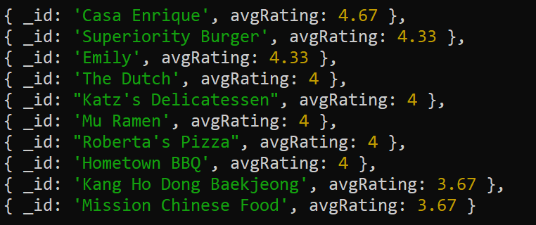

1. Unwind the restaurants collection and show the average rating, min rating and max rating per restaurant and sort them by avgRating in descending order

(the output image is in ascending order if you wanted descending change sort 1 to -1)

db.restaurant.aggregate

(

{"$unwind" : "$reviews"},

{"$group" :

{

"_id" : "$name",

"maxRating" : {"$max" : "$reviews.rating"},

"minRating" : {"$min" : "$reviews.rating"},

"avgRating" : {"$avg" : "$reviews.rating"}

}

},

{"$sort" : {"avgRating" : 1}}

)

Output:

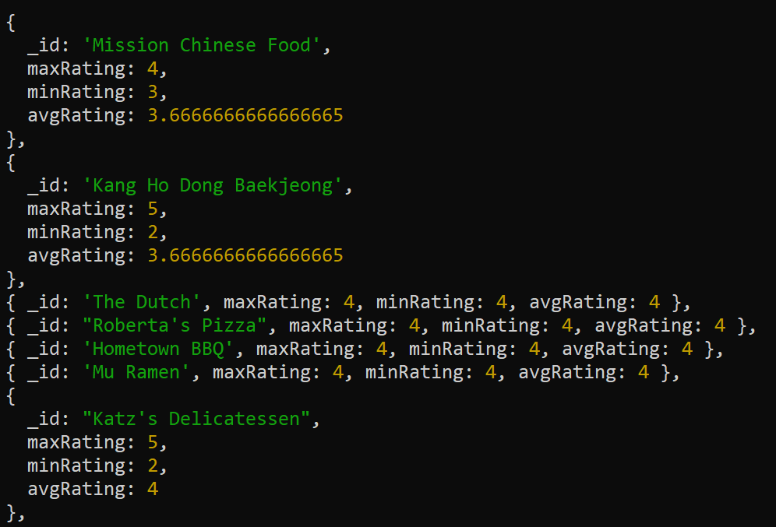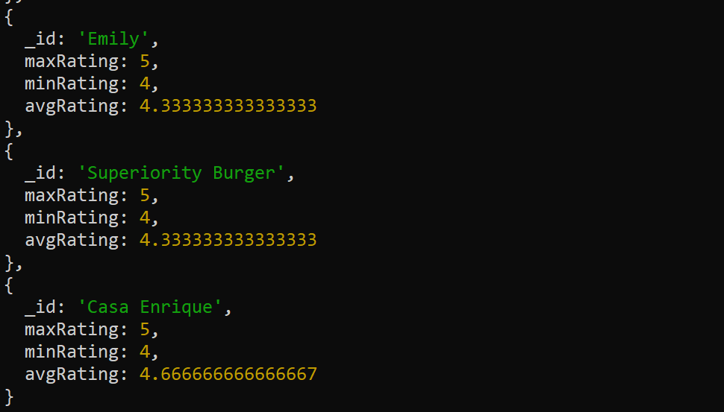

**Aggregation commands:**

**distinct**

1. Show the list of distinct cuisine types. Use the runCommand() function on the database.

db.runCommand({distinct : "restaurant", key : "cuisine_type"})

Output:



1. Show the list of distinct user names who provided reviews on the restaurants in the collection. Use the runCommand() function on the database..

db.runCommand({distinct : "restaurant", key : "reviews.name"})

Output:

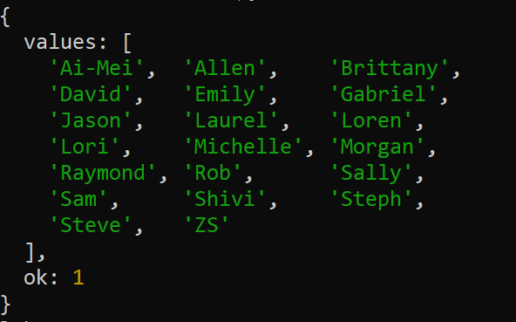

SUBMISSION

Submit your lab10_Groupxx.doc file on BB.

Also submit lab10_groupxx.txt file with only the question text and the command answer in text.

Marking: q 1-3: 5 marks each, q4, 5: 2pts each